HM703 Automatic oleic acid tester

Manual of operationmanual of operation

Before using this product, please read the operation manual carefully and keep the operation manual for future reference

Baoding Da Heng Electric Technology Co., Ltd

Orders to record
Before the speech 3
one,We mentioned 5
two , the technical indicators 7
Three, use conditions 8
Four parts, chassis and panel 8
Five, the diagram of operation steps 9
six . Maintenance 17
seven . Complete sex instrument 20
Eight. After-sales service and maintenance 21

Before the speech
Dear users:
Thank you for choosing the type DH703 Automatic oleic acid tester!For the convenience of you familiar with the instrument as soon as possible as soon as possible, we provided the detail operation manual, from which you can get the product introduction, the use of methods, equipment performance, and security considerations, and many other aspects of the information.
Before the first use of the instrument, please be sure to read the manual carefully, and according to the manual of instrument operation and maintenance, this will help you better use of the product, and it can prolong the service life of the instrument.
At writing manual, although we in line with the scientific and rigorous attitude for work, and that the information provided in this manual are correct and reliable.However, even Homer sometimes nods, this manual also hard to avoid can have errors and omissions.If you found error, please be sure to in spite of being very busy toglance take time, try to inform the company relevant personnel as soon as possible, and please supervise us correct errors quickly!The company all staff will be appreciated!
The company reserves the right to improve the instrument use function, such as found in the process of using the function of the instrument and operation manual to introduce inconsistencies, please based on the actual function of the instrument shall prevail.We hope that the instrument can make your job easier, happy, to you in the busy work realize office automation of relaxed and happy feeling!
When you are satisfied with our instruments, please recommend to your friends!When you have valuable advice and Suggestions to this instrument, please be sure to contact us, we will try our best to give you a satisfactory answer.Once again thank you for your support to our company!

one,We mentioned
DH703 Automatic oleic acid tester is easy to operate, beautiful shape.Instrument adopt fully automatic digital computer control to acid and alkali neutralization reaction of chemical analysis as the basic framework, with the background of the self-developed deduction, and logical decision process of titration end point blank, so the measurement precision and accuracy are ideal.
Transformer and turbine oleic acid value detection is electric power system and industrial and mining enterprises of oil-filled electrical equipment regular inspection items, while type DH703 Automatic oleic acid testeris my company for the determination of oil acid value and the development of special equipment.The instrument with single chip microcomputer as the core, set light, machine, electricity and chemistry of multidisciplinary technology.Basic entirely replace the manual operation, improve work efficiency, and reduce the labor intensity of operators and minimize the organic solvents and other chemicals to the harm of human body.
Type DH703 oleic acid value tester using neutralization principle, interesting state, the microcomputer control automatically add liquid, mixing, end point of titration and judgment.Adopt touch LCD screen to select all working parameters, friendly man-machine dialogue interface simple, easy to operate, sample analysis cycle for an average of two minutes.Respectively shows up to 35 sets of determination results, and can print multiple determination of related parameters.
Using special reagent bottle holding extract and neutralization liquid.Extract of using glass container storage to ensure that no plastic additives pollutants.Neutralization liquid storage choose polyethylene plastic, completely avoid the caustic potash may react with glass.In addition, to develop the neutralization liquid Equilibrium gas solid purification device, completely avoid the carbon dioxide and water vapor to counteract the effect of liquid concentration, more will not happen wrong high concentration of caustic potash or caustic soda purification solution used as standard solution titration of the accident.Users don't need to hand in the process of work contact with organic solvent, reduce the harm of the chemicals on the human body.
According to user requirements, DH703 Automatic oleic acid tester of 1 ~ 3 sample.

two , the technical indicators
1. The linear range: 0.001 ~ 0.900 mgKOH/g;
2. The correlation coefficients: 0.999 ~ 0.9998
3. Return to charge rate: 98 ~ 103%
4. The minimum resolution: 0.001 mgKOH/g
5. Repetitive: 2 ~ 5% (RSD)
6. Measurement accuracy:
Acid value between 0.001 ~ 0.100 mgKOH/g is plus or minus 0.003 mgKOH/g;
Acid value in 0. 100 ~ 0.900 mgKOH/g is in value between 2 ~ 5%;
7. Display: large screen touch color LCD screen to Chinese characters display (full)
: (wide) 8. Overall size 420 mm * 190 mm (high) * 340 mm (depth)
9. Net weight: ~ 9 kg

Three, use conditions
1. 0 ~ 40 ℃ ambient temperature
2. The relative humidity of 85% or less
3. Work power AC 220 v + / - 10%
4. Power frequency 50 + 5 Hz
5. Power consumption < 150 W

Four parts, chassis and panel
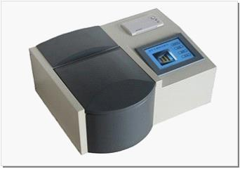
Figure 1 case appearance
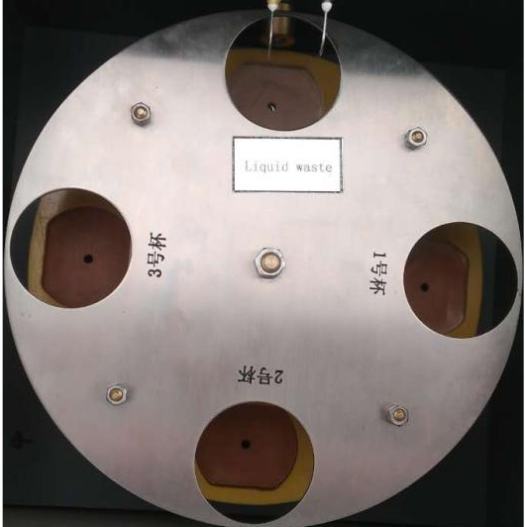
Figure 2 sample determination of dark room
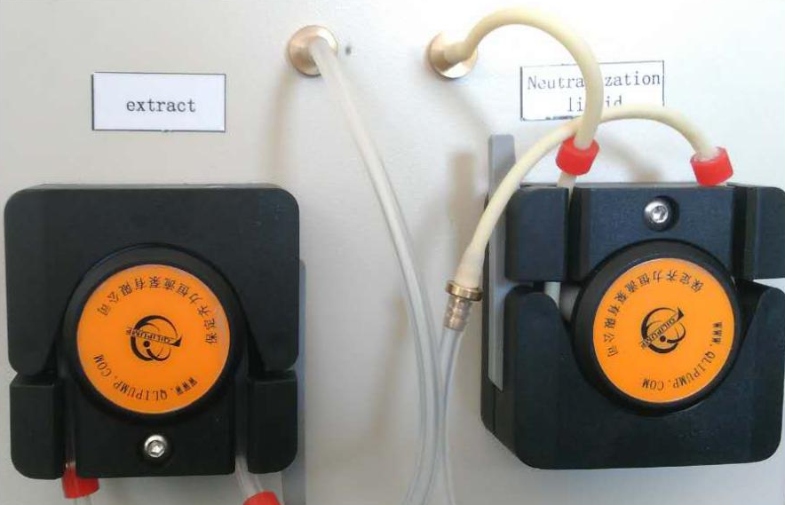
Figure 3 extract and neutralization liquid peristaltic pump

Five, the diagram of operation steps
1. Plug the power cord, open the power switch, LCD shows on the page (figure 4)
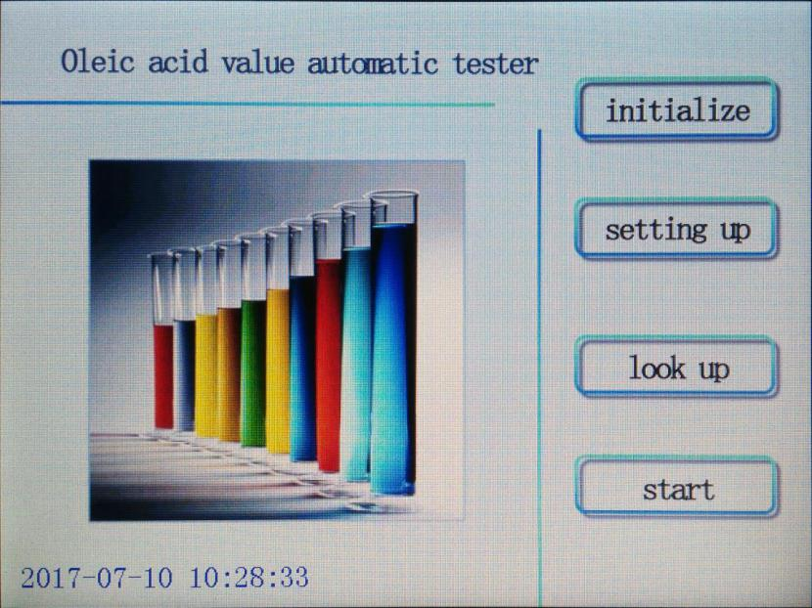
Figure 4 on page

- Under the page shown in figure 4, according to the initialize button to enter the next level page (figure 5);
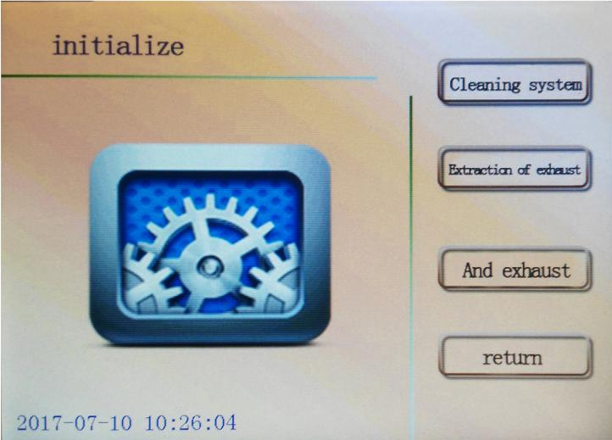
Figure 5 initializes the page
3.under the page shown in figure 5, open the sample determination of darkroom cover, with the hand gently upon oil cup dish, make the waste liquor cup hole position deviation titration.In a oil cup into the waste liquor cup hole, press system cleaning system will be automatically extracted and neutral line cleaning, cup will undertake cleaning wastewater.Cleaning system page is shown in figure 6;
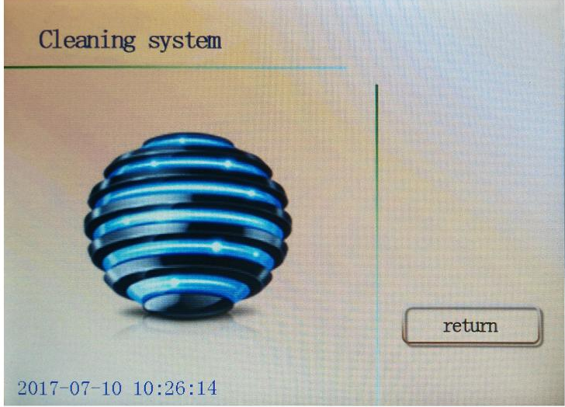
Figure 6 system clean page
4. System cleaning after the completion of the press the return key to return to initialize the page (figure 5).On the page shown in figure 5, press extraction exhaust, open the sample determination of darkroom cover at the same time, observe the exhaust condition, until no visible air bubbles out, press the return key to return to initialize the page (figure 5).The same steps to neutralize the exhaust.
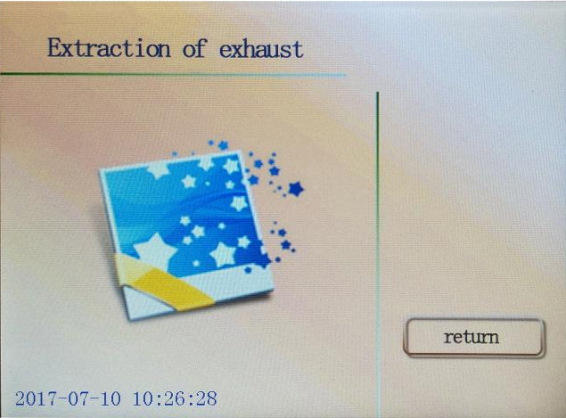
Figure 7 extraction exhaust page
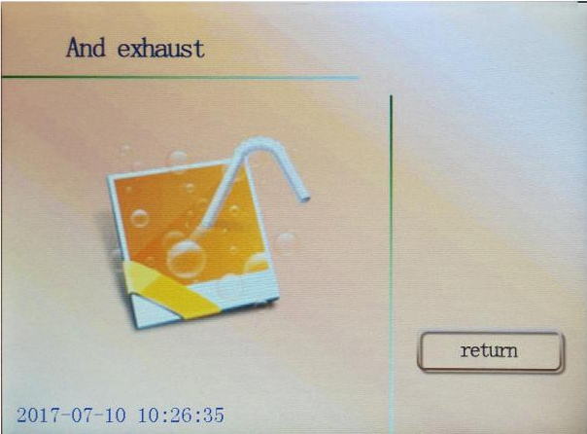
The figure 8 and exhaust page
5. After completion of initialization, shown in figure 5 to initialize the page press the return key to return to boot page, press set button to enter Settings page (figure 9).
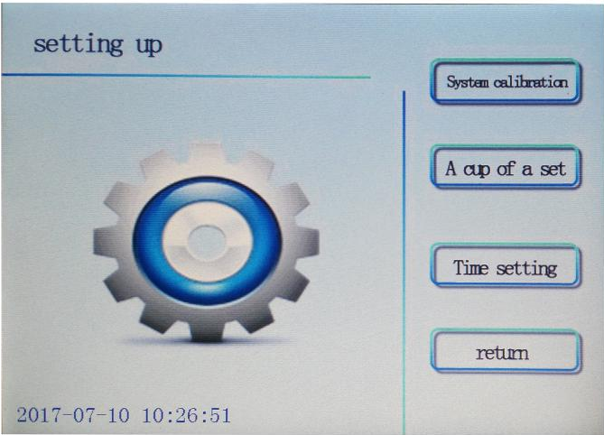
Figure 9 Settings page
- Under the figure 9 page, according to the system calibration button to enter system calibration page (figure 10).
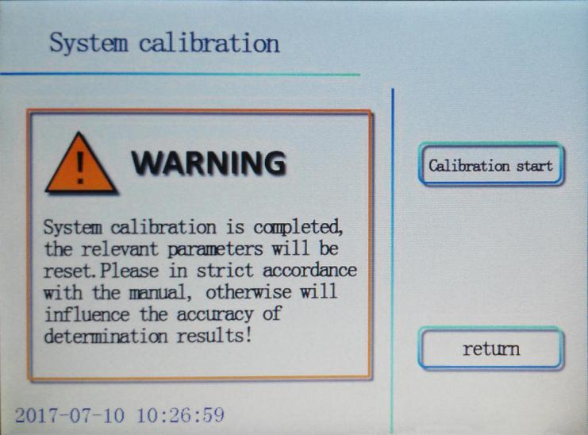
Figure 10 calibration system page
Open the sample determination of darkroom cover, in 1, 2 cups of oil cup each with 1 bottle of standard acid, according to the calibration start button on the system calibration.Including the standard acid used in the calibration system error in the no. 1 cup, 2 cups of standard acid is used to verify the calibration results.In the process of calibration figure 11 pages.After the completion of the calibration, as shown in figure 11 page will display the calibration results of the system,
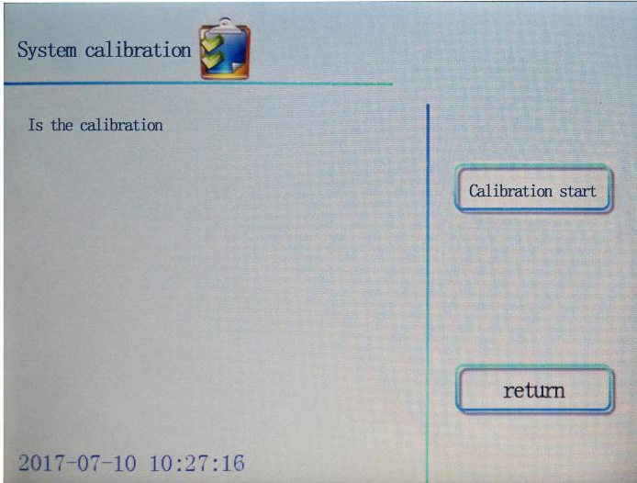
Figure 11. System calibration of the page
The theoretical value of 0.067 mgKOH/g and the measured values can be close to the theoretical value, general requirements strictly, should guarantee the calibration value in the range of 0.067 + / - 0.003 mgKOH/g.Allowed error is large, can be adjusted according to actual situation.
7. The Settings page, click set cup a cup set button to enter a page (figure 12), press the select key pick cup number, press Yes or No command a determination to participate in or not to participate in the cup.
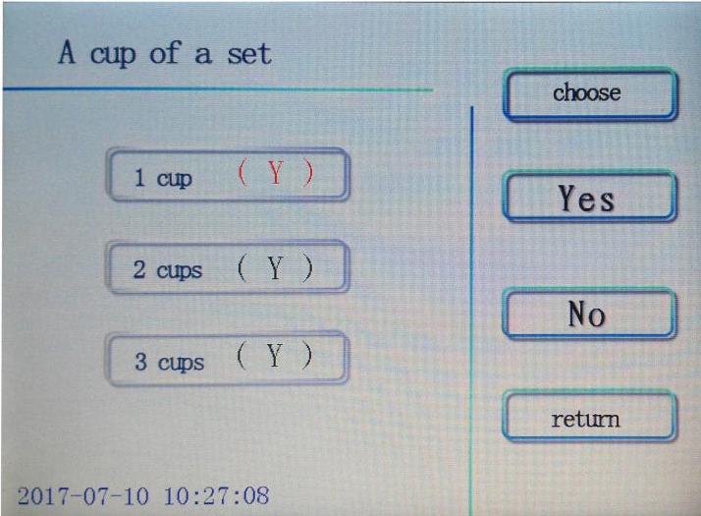
Figure 12 cup Settings page
- The Settings page, press set button to enter the time setting page (figure 13), press the select key select year, month, day, hours, minutes, press the + or - key change the set point, and then press the return key back to the Settings page.
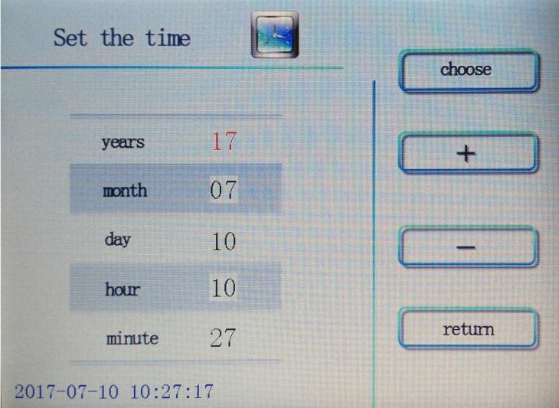
Figure 13 time setting page
- Before the formal sample determination, clean oil cup sample shall be placed in the corresponding cup hole, in the determination of each oil cup accurately parallel oil injection sample under test 10.0 mL, stir and add a magnet, was used to determine the darkroom cover cover.On page (figure 4) press the start key are measured, at the same time display shows the test page, the screen in different test phase respectively show "X cup test, please later...", "are titration", after the completion of the measurement also shows the value of the titration end point (EP) (figure 14) and the "test" (figure 15).
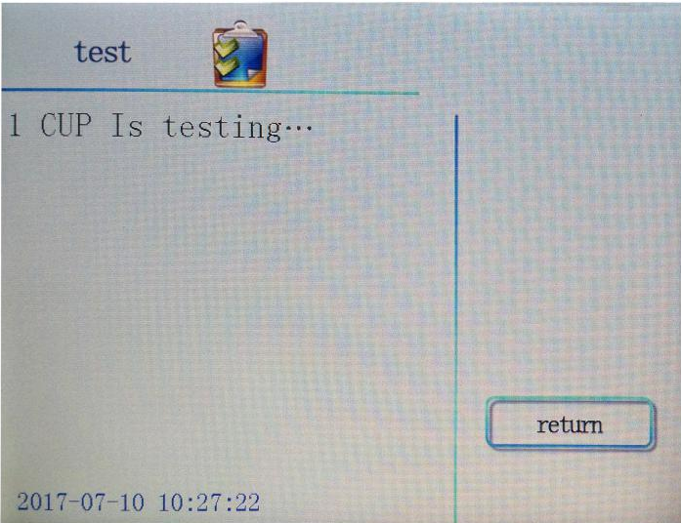
Figure 14
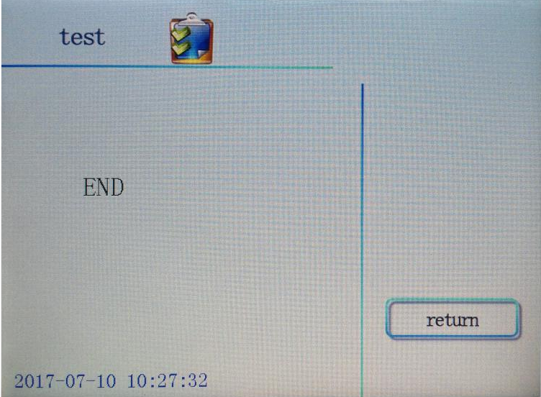
Figure 15
10. After completion of measurement, the machine automatically saved 35 sets of data.Operator if you want to consult, please press the return key to enter boot page (figure 4), click the view button to enter refer to page (figure 16), click on the back or on the next page button to view no. 01 ~ # 35 sets of data, click on print button to output data needed by the printer.
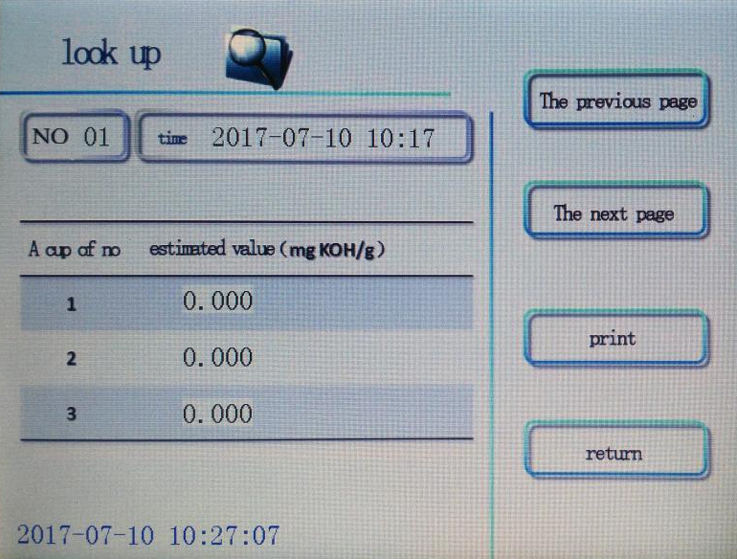
Figure 16

six . Maintenance
After each use, extract and neutralization liquid infusion peristaltic pump pressure plate must loosen, prevent infusion pump pipe has long been extrusion deformation and adhesion, affect the measurement precision and accuracy;
2. After each use, must be washed with anhydrous ethanol and fluid, extracted liquid transfusion pipe, prevent precipitation clogging pipeline and micro titration needles;
3. The infusion pump pipe in the middle, long after use, if discover the obvious deformation or adhesion, must be paid to the maintenance or replacement.Replacing pump pipe, remove the groove of the pump pipe from the peristaltic pump, change new pump pipe, the same back and with the relevant parts can be properly connected;
4. Replace the extracted liquid and neutralization liquid, should be used, under the solution bottle of bottle, and then put on the new solution to replace piping should be paid attention to the problem of pollution in the process of;
5. When carbon dioxide and water vapour cleaning agent after apparently color changed from pink to pale, should be replaced, and should not continue to use, otherwise it will affect the stability and liquid, until the accuracy of determination results;
- Replace the printing ribbon:
Foil box, at the time of the printer factory to pack good, but after a period of use, need to replace the ribbon box.Can press the following steps to replace the ribbon box.
(1) well with warehouse.
(2) from the printer head gently remove the old foil box.Note: please lift the left end of the ribbon box, then lift the ribbon in a box right end, remove the foil box.
(3) change box new ribbon.First will foil box right end gently on the nose gear shaft to the right, left side slightly raised, don't put down.Then found the ribbon box right end to fall to the end, please hold the knob on the ribbon box with finger, clockwise rotate slightly, until the ribbon box right end fall down again after the ribbon box of left side.Please check whether the ribbon is straight, or ribbon is dew outside the foil box, can again turn knob on the foil box, until the ribbon into ribbon box and straighten.When there is no paper in the nose, easy replacement ribbon.
(4) push the ribbon warehouse into the reset, completed.
7. Replace the paper:
Pull (1) the paper storehouse, remove the paper scroll replacement of printing paper, and the paper scrolls inside the guide groove of pushing into the printer.Make sure paper scrolls have installation is firm, do not lose out.
(2) the paper cut into triangles, switch the instrument on, according to the SEL button (left), make the SEL light out, and then press the LF (right) key, turns head.Then the paper with the hand into the nose mouth, the following paper paper will slowly into the nose, until it emerged from the nose in front, should have a certain length.Press the LF or SEL key again, or turn off the power.
(3) the paper warehouse push reset.

seven . Complete sex instrument
1 1. The device
Article 2. The power cord 1
3. Insurance tube (3 a) 2 only
4. Oil cup four
5. Stir bar 4 only
6. The neutralization titration needle 1 only
7. Add liquid needle 1 only
Article 8. The extraction liquid pump pipe 1
Article 9. The neutralization liquid pump pipe 1
10. The extraction solution 2 bottles (2 x 500 mL)
11. The neutralizing solution 1 bottle (1 x 250 mL)
12. 2 bottles of standard acid (6 x 5 ml)
13. Printing paper 1 (
14. Tweezers 1 -
15. The injector 1 a

Eight. After-sales service and maintenance
1. The product warranty for 12 months, life-long service.
2. The company perennial supply related reagents and consumables.

